Annual Performance Report
  - Investment Review

Annual Report
All prices are as of 21.12.25

2025 Year-End Review and Performance Update
As we conclude 2025, I compiled an overview of this years stock returns. Overall, portfolio performance was very strong in 2025 with a total return of 37.93%. This compares with a 16.46% return of the S&P 500 index, and a 19.41% in the MSCI World, which is a diversified index of all major stock companies across the world.
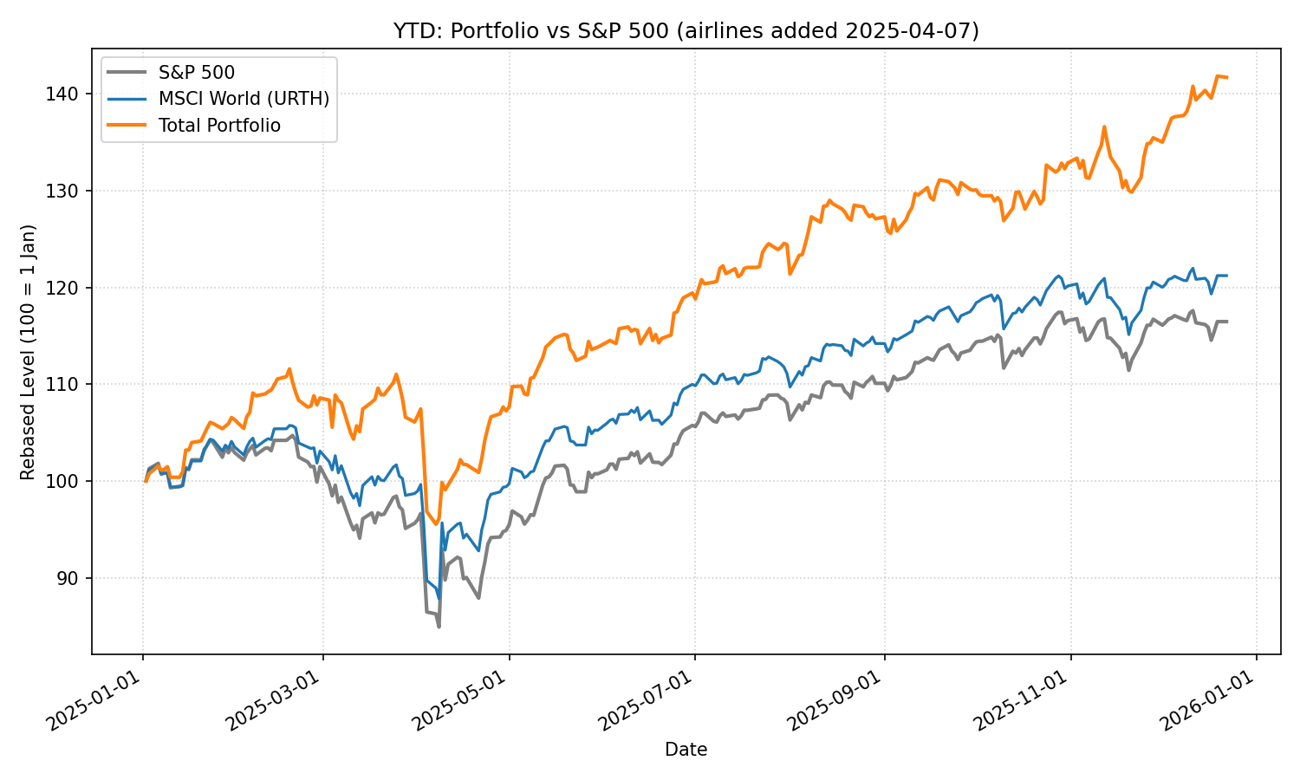

Market Environment
This year was characterized by heightened market volatility, with macroeconomic uncertainty driven by eratic US economic policy. This uncertainty could be exploited by buy assets for depressed prices in the wake of “tarif day”. This constituted this years largest buying/selling in the portfolio, using cash reserves to double the position in 3Bal.L (a leveraged index fund of bank stocks) and open new positions in United Airlines and Southwest Airlines. These positions have since increased by 291.42%, 80.14%, and 52.01% respetively.

The following graph shows the S&P 500 in grey, normalized to the buying day (April 7th marked with the dotted line) and the new positions in blue, orange and green respectively.
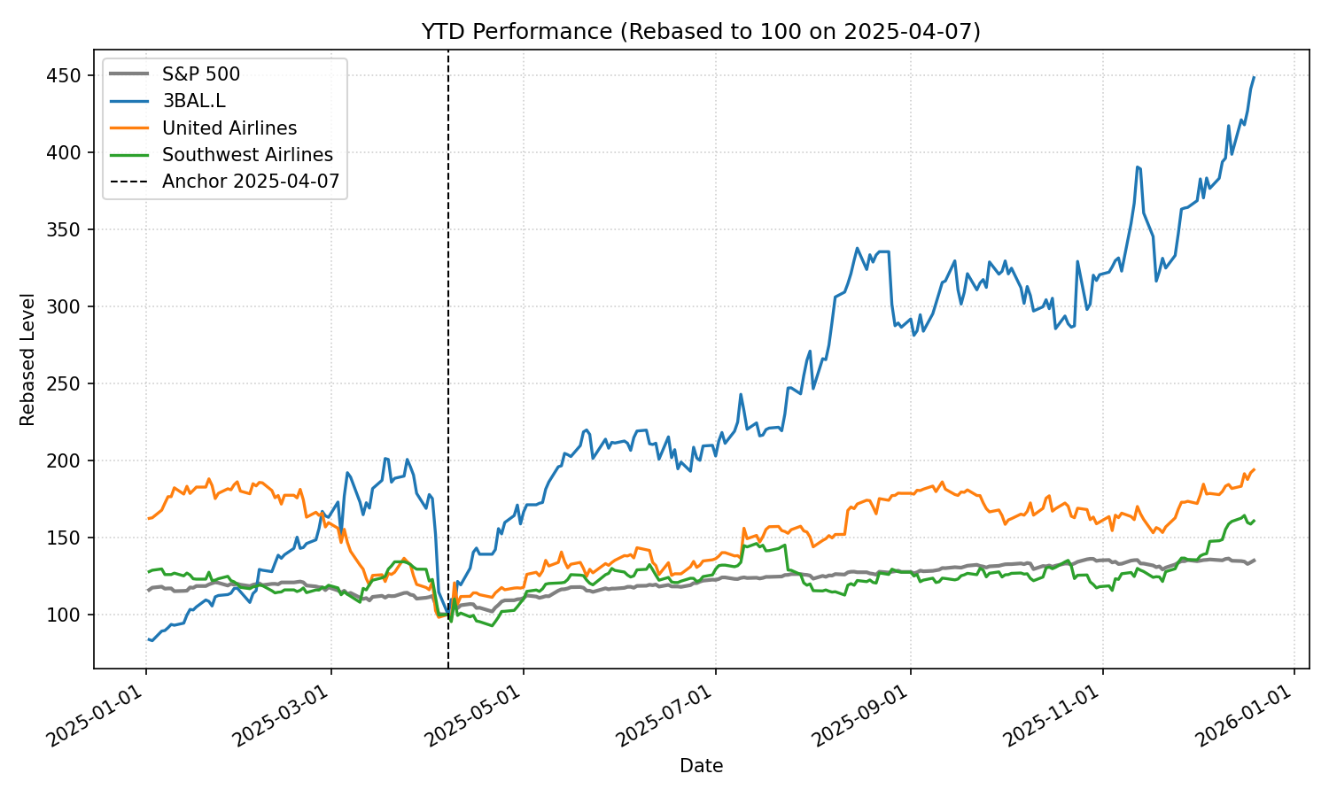

3. Key Contributors and Detractors
- Contributors: Beyond strong general market performance the main contributors to this years success were strong performance by the outsized position in Heidelberg Materials (4th best performer in the DAX 40), Palantir (8th best performer in the S&P 500): Furthermore, large positions in US banks (Wells Fargo, Citigroup, Goldman Sachs) outperformed the general stock market (average return of 30.64%).
- Detractors: The worst performing asset this year was the cash reserve which only increased marginally in value. The three other underperformers were the German chemical producer Covestro (+ 3.36%) which is currently being aquired by the Emiratis. The Covestro position served as a liquid cash-like asset, because the Emiratis purchase agreement is legally binding. The other underperfomers this year were the hedging positions against high oil prices. Shell and BP (+1.2% and +5.56%) would both be well positioned to exploit an increase in oil prices (which inturn would hurt other portfolio companies like Heidelberg Materials). Due to relative stability in the Middle East and record breaking oil discoveries in highy secure and technically capable locations (mostly US), this did not happen.

4. Risk Management and Strategy Adjustments
We The portfolio consists of roughly 25% cash and cash-equivalents which are very low risk, 35% diversified index funds which are considered light to medium risk, 35% single stocks, which are medium to high risk and 5% leveraged positions which are very high risk. Overall, this risk mixture allows for high risk-adjusted returns which decent downside protection.
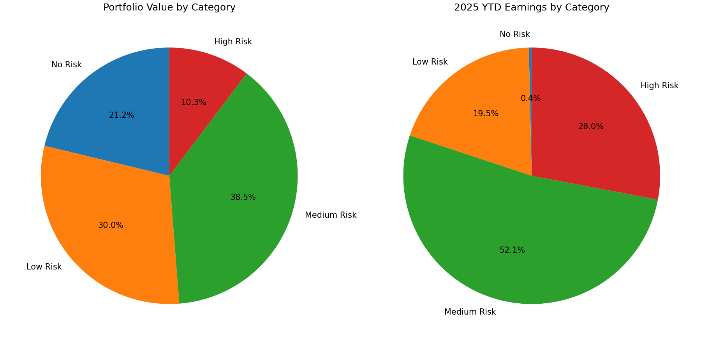

5. Fees & Taxes
The portfolio chares 0% fees on invested capital and 0% fees on capital gains. This compares favourably to the industry standard 2% and 20%. All gains are taxed in Germany at point of sale. Listed prices are pre-tax prices.

6. Total Worth/Gains
Your current portflio value is 238.508,30 EUR. This is split in invested capital worth 130.000 EUR and capial gains worth 108.508,30 EUR.

With that I wish a Merry Christmas, a happy New Year, and lots of investment success in 2026!

Christian

